World History Unit One Exam
History – Early Civilizations

- The record of past events and times, especially in connection with the human race is the best definition of…
  - Anthropology
  - Archeology
  - History
  - Science
- A person who digs up then examines and analyzes stuff others left behind is called a…
  - Anthropologist
  - Archeologist
  - Historian
  - Scientist
- The study of human life and culture is…
  - Anthropology
  - Archeology
  - History
  - Science
- Which of the following are considered artifacts?
  - Written Documents
  - Tools
  - Weapons
  - All of the above
- Material that is closest to the person, information, period, or idea being studied is called a…
  - Primary resource
  - Secondary resource
  - Artifact
  - Fossil
- Which of the following are examples of primary resources?
  - Memoirs (fancy word for a diary)
  - Autobiographies (stuff about themselves)
  - Recorded interviews (stuff about others)
  - All of the above
- Which of the following are more helpful to anthropologist and archeologist in discovering the truth behind a historical event or person?
  - Written documents
  - Secondary resource
  - Bones
  - Fossil

- The time before writing was developed that is also very closely tied to the beginnings of agriculture is called…
  - Neolithic Age
  - Modern Age
  - Pr-modern Age
  - Prehistory
- During the Paleolithic age people …
  - Wandered around hunting and gathering
  - Lived in large cities
  - Lived in huts near rivers
  - Played basketball with real blue devils
- We know that the earliest humans
  - Had belief systems and wandered in small groups
  - Had no belief system and wandered in large groups
  - Worshiped Coach Peeler and were Tarheel fans
  - Were sacrificed by Tarheels because they worshiped blue devils
- Humans began the domestication (using them) animals and growing crops around the year 8,000 BC. This period is called the …
  - Paleolithic Age
  - Stone Age
  - Neolithic Revolution
  - Peeler Age of Reason
- Which of the following was NOT an impact of the Neolithic Revolution?
  - Increase food supplies
  - Job specialization
  - Industrialization of business
  - Live in homes and cities
  - Women’s roles change
  - Population increase
- Which of the following is NOT a characteristic of all civilization?
  - Large cities
  - Obelisk are raise
  - Public buildings
  - Common language
  - Written language
  - Art work
  - Trade
  - Infrastructure (roads, irrigation)
- Which of the following are advantages of civilizations
  - Develop skills and inventions
  - Increased protection of people
  - Improve quality of life
  - All of the above
- Which of the following are disadvantages of civilizations
  - Land depletion
  - Increased attacks of outsiders and crime from inside
  - Threat of disease
  - All of the above
- What was the major “marker event” or “turning point” in early human history?
  - Paleolithic Age
  - Flash Age
  - Neolithic Revolution
  - Peeler was born
- What three important changes occurred during the Neolithic Era?
  - Dinosaurs died
  - Inventions, religions, and skills declined
  - Use of electronics, medicine, and metals
  - Development of the plow, bronze, and writing
- One common characteristic of early civilizations is they all lived near...
  - Rivers
  - Mountains
  - Cheese crackers
  - West Express
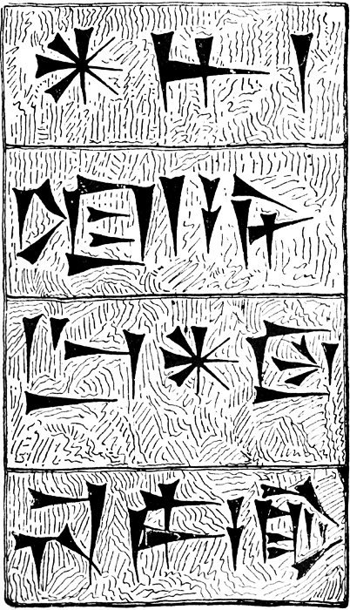
- The Sumerian people lived in the area of ancient …
  - Ayria
  - Iraq
  - Mesopotamia
  - Egypt
- The Egyptians lived in the area of…
  - Ayria
  - Iraq
  - Mesopotamia
  - Egypt
- The Shang people lived in the area of …
  - China
  - India
  - Mesopotamia
  - Egypt
- Which of the following is not a common characteristic of River Valley Civilizations?
  - Located in river valley
  - Complex irrigation systems
  - Development of legal codes
  - Lived on mountain tops
  - Use of Money
  - Art forms
  - Scientific knowledge (calendars)
  - Social inequality
- Mesopotamia is located in modern day …
  - Iran and Iraq
  - Syria and Libya
  - Egypt and Israel
  - American and Canada
- Ancient Mesopotamian Kings and Priests lived at the top and center of large structures called…
  - Temples
  - Ziggurats
  - Acropolis
  - Skyscrapers
- The ancient Mesopotamian religious story was called …
  - The Prince of Egypt
  - The story of Moses
  - Epic of Gilgamesh
  - Isis ad Osiris epic
- The oldest ancient form of writing is found in Mesopotamia and is called …
  - Cuneiform
  - Hieroglyphics
  - Sanskrit
  - Cave drawings
- A religion that is based on the belief in one God is called?
  - Monotheism
  - Polytheism
  - Babylonian
  - Christianity
- The picture to the right is an example of which of the following ancient
writing system?
  - Cuneiform
  - Phoenician
  - Hieroglyphics
  - Standard Alphabet
- One common social theme across the early civilizations was…
  - God kings
  - Women queens
  - Picture graphic writing
  - Slavery or class system
- Ancient Egypt was located along which of the following rivers?
  - Amazon
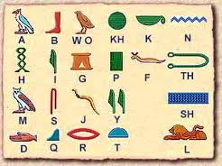
  - Colorado
  - Nile
  - Mississippi

- The picture to the left is an example of which of the following ancient
  - Cuneiform
  - Phoenician
  - Hieroglyphics
  - Standard Alphabet
- The ancient Egyptians built large _______________ to place their dead as a symbol of their belief in the afterlife.
  - Pyramids
  - Coffins
  - Tombstones
  - Caves
- The leader of Egypt was called?
  - Pharaoh
  - King of Egypt
  - Moses
  - Hatshepsut
- One common religious theme across the early civilizations was…
  - Pyramids for the dead
  - Large temples of worship
  - Churches with steeples
  - Polytheism
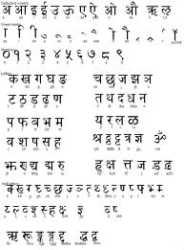
- The writing to the left is an example of which of the following ancient
  - Cuneiform
  - Phoenician
  - Hieroglyphics
  - Sanskrit

- What are two theories of what happened in the decline of earl y civilizations?
  - Outside invaders and interaction with others
  - Flood and Famine destroyed them
  - Aliens and /or Dinosaurs ate them
  - Peeler and/or Flash destroyed them with plagues of sun drop and chocolate
- Which of the following migrating groups ended up in Egypt as slaves and were delivered by their God in a dramatic confrontation with the Egyptian gods and the parting of the Red Sea?
  - Phoenicians 2000 BC
  - Israelites 2000 BC
  - Aryans 1500 BC
  - Shang China 500 AD
- What was the unique feature about the Israelites that distinguished them from all other civilizations in the ancient world?
  - They were monotheistic
  - They had a system of government called a democracy
  - They wore white robes
  - They ate only sun drop and chocolate
- A belief system that is based on the belief in many gods is called?
  - Monotheism
  - Polytheism
  - Babylonian
  - Christianity
- Paleolithic people moved from place to place following animal migrations and vegetation cycles. This pattern of living is called
  - Old Stone age
  - Hominids
  - Nomadic
  - Archeology
- What was the site of the first recorded battle in mankind’s history?
  - Egypt
  - Megiddo
  - Babylon
  - Jerusalem
- According the to theory presented in the ‘Story of Us” the earliest human civilizations could have began around which of the following
  - Gardens
  - A fire
  - Caves
  - Battles
- According to the mankind story of us the earliest leaders of civilizations were?
  - Men who were the strongest
  - Men who were smartest
  - Women who planted gardens
  - Democracies
- Which of the following was most helpful in organizing large numbers of people to build such large project like the pyramids?
  - Writing
  - Leaders
  - Machinery
  - Trading

- In the earliest recorded battles we know the Egyptians use a modern warfare of?
  - Tanks and bombs
  - Weapons of mass destruction
  - Organized ranks, platoons and regimens
  - The gun
- What was used to make bronze?
  - Copper and Iron
  - Iron and tin
  - Cooper and tin
  - Salt and Iron
- Which of the following was the most important factor influence on settlement in the earliest civilizations
  - Geography
  - Leadership
  - Threat of disease
  - Threat of invasion by animals
- The area of Mesopotamia is also known as
  - The garden of Eden
  - Jerusalem
  - Europe
  - Fertile Crescent
- Which ancient leader codified laws to meet the needs of his ancient society?
  - Hatshepsut
  - Abraham
  - Hammurabi
  - Justinian
- What was one of the earliest occupations that proved to be a very dangerous one?
  - Fishermen
  - Bankers
  - Builders
  - Traders

Essays (Choose ONE)

Analyze the development, growth and lasting impact of the ancient empires we discussed in class?

Compare how different geographic issues influenced settlement, trade and sustainability of various ancient civilizations?

