Unit Seven Imperialism – WWII Exam

- Question one will go here…..
  - Choices C and D will automatically pop up when you hit enter

- Question two will go here
  - To place a picture in the document you must go to the ppt, copy it, then paste it on your test, then crop it to fit.

- Example question using the picture to here would say…”Which of the following words would best describe the picture below.
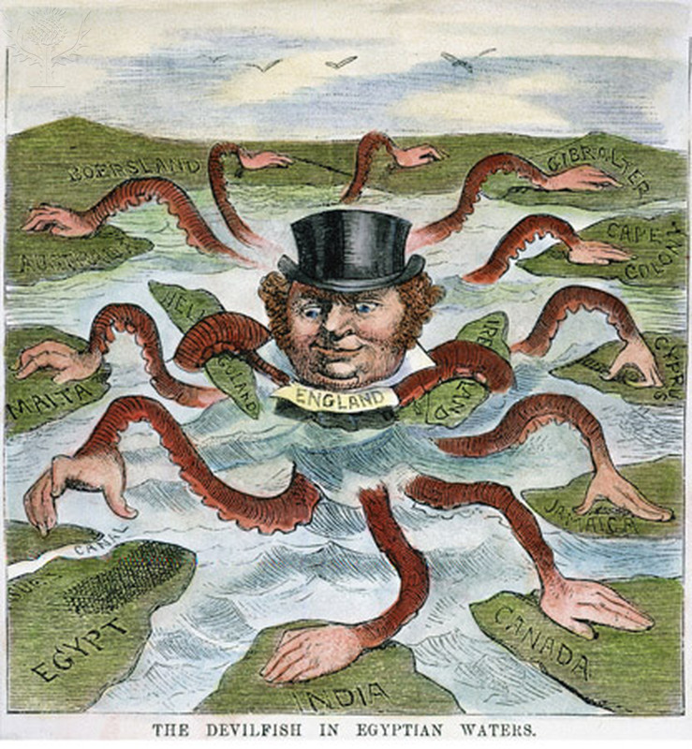
  - Imperialism
  - Civil War
  - Britain’s got talent
  - Octopus’s are taking over

