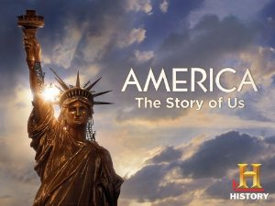

Jamestown

- How many settlers were remaining at Jamestown when John Rolfe returned?
- Why was the man being burned at the stake?
- What kind of seeds did John Rolfe smuggle from the Carribean?
- Who did John Rolfe marry?
- What is the crop that will make Jamestown a “Boom Town”?
- What brought the need for slaves?
- How many years after the settlement were slaves introduced?

Pilgrims

- How many mile North of Jamestown did the Pilgrims settle?
- How many Pilgrims died in the first 3 months?
- Who was the leader of the Pilgrims?
- What percentage of Americans can trace their heritage back to the Pilgrims?
- What do the Native Americans teach them to use as fertilizer?
- What did the Natives want in exchange for the help with food?
- Did Pilgrims and Natives live in peace?

Boston

- Whose boat were the smugglers using?
- How many red coats were there for every colonist?
- Were the 13 colonies considered a Economic Powerhouse?
- What item was used to purchase African slaves?
- Who was Crispus Attucks?
- Who created the engraving of the Boston Massacre?
- Who introduced the postal system that connected the colonies?

Rebels

- Why did people settling in the West get evicted from their homes?
- What did the 1st Continental Congress decide?
- Where did the 1st Continental Congress meet?
- What is Militia?
- How important was the militia going to be in a war?
- List two men at the 1st Continental Congress?

