Sacco and Vanzetti Case Summary

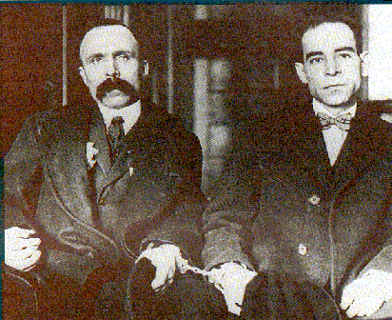

- When?

- Brief background of the case?

- What was the verdict?

- What was the sentence?

- What is the significance of this case on U.S. history?

- Do you think these men received a fair trail and can you relate this to any situations in U.S. history that you know of?

