House of Burgesses
U*X*L Encyclopedia of U.S. History, 2009

Listen

's House of Burgesses was the first representative assembly in North America. It was created by Governor George Yeardley (c. 1587–1627) under instructions from the Virginia Company of London, which owned the colony of Virginia. In hope of attracting more immigrants to its colony, the company replaced a form of martial law used by the colony's previous governor with English common law.
The new system provided for local governments as well as a general assembly for the whole colony. Virginia was organized at first into cities, or boroughs. Monthly courts were created in 1622. Further legislation created shires in 1634 and counties in 1642. The general assembly was called the House of Burgesses. It contained representatives from each of the local boroughs.
The House of Burgesses borrowed its name from the House of Commons in England, whose representatives were called burgesses. It
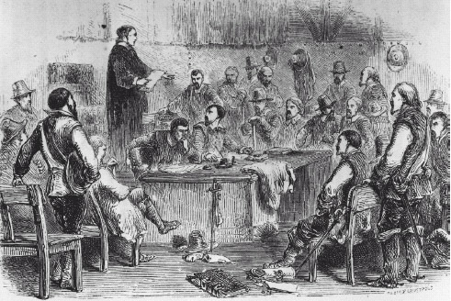
functioned as a simple parliament that passed legislation for the entire colony of Virginia. The Virginia Company appointed a governor and a council as part of the legislature. The other members were elected, two by each of Virginia's ten settlements.
The first elected assembly gathered in the House of Burgesses on July 30, 1619, in Jamestown. It met for five days. There were twenty-two members present. The House of Burgesses continued to meet annually, even after the dissolution of the Virginia Company in 1624 brought the colony under direct royal control.
Full Text: COPYRIGHT 2009 Gale, Cengage Learning.

